|  |  |  |  |  |
| --- | --- | --- | --- | --- |
|  |  | | |  |
|  | | |
|  | | |
|
|  | **xFusion FusionDirector for vROps**  **2.0.1**  **User Guide** | |  |  |
|  | |
| **Date** | **2022-01-30** |
| Copyright © Copyright Holder. All rights reserved. | |

|  |
| --- |
| Notice  The information in this document is subject to change without notice. Every effort has been made in the preparation of this document to ensure accuracy of the contents, but all statements, information, and recommendations in this document do not constitute a warranty of any kind, express or implied. |

Contents

About this Document v

1 Overview 7

2 Managing the vROps Plug-in 9

2.1 Installation 9

2.2 Uninstallation 12

2.3 Upgrade 14

3 Configuring FusionDirector 15

3.1 Addition 15

3.2 Modification 24

3.3 Deletion 27

4 Querying Server Information 29

4.1 Querying Servers 29

4.2 Querying Component Information 31

4.3 Querying Component Group Information 34

4.4 Querying Server Information 35

4.5 Querying Server Type Information 35

4.6 Querying the FusionDirector Information 36

5 Querying Enclosure Information 37

5.1 Querying Enclosures 37

5.2 Querying Component Information 38

5.3 Querying Component Group Information 41

5.4 Querying Enclosure Information 41

5.5 Querying the FusionDirector Information 42

6 Querying Dashboard Information 44

6.1 Querying the FusionDirector Overview Dashboard 44

6.2 Querying xFusion Servers Overview Dashboard 44

6.3 Querying xFusion Server Detailed Dashboard 48

6.4 Querying xFusion Enclosure Overview Dashboard 49

6.5 Querying xFusion Enclosure Detailed Dashboard 50

7 Viewing Alerts 52

8 Querying the xFusion vROps Plug-in Version 54

A Obtaining Technical Support 55

About this Document

Overview

This guide describes how to install and maintain the vRealize Operations Manager (vROps) plug-in.

Intended Audience

This guide is intended for:

* Technical support engineers
* System maintenance engineers

Symbol Conventions

The symbols that may be found in this document are defined as follows.

| Symbol | Description |
| --- | --- |
|  | Indicates an imminently hazardous situation which, if not avoided, will result in death or serious injury. |
|  | Indicates a potentially hazardous situation which, if not avoided, could result in death or serious injury. |
|  | Indicates a potentially hazardous situation which, if not avoided, may result in minor or moderate injury. |
|  | Indicates a potentially hazardous situation which, if not avoided, could result in equipment damage, data loss, performance deterioration, or unanticipated results.  NOTICE is used to address practices not related to personal injury. |
|  | Calls attention to important information, best practices, and tips.  NOTE is used to address information not related to personal injury, equipment damage, and environment deterioration. |

Change History

Changes between document issues are cumulative. The latest document issue contains all the changes made in earlier issues.

| Issue | Date | Description |
| --- | --- | --- |
| 01 | 2022-01-30 | The issue is the first official release. |

# Overview

Function Description

The FusionDirector for vROps plug-in can be used to manage and monitor servers. Only vRealize Operations Manager 8.0 and 8.1 are supported. This document uses vRealize Operations Manager 8.1 as an example.

The FusionDirector for vROps plug-in provides the following functions:

* Query the basic information about severs and enclosures (also referred to as chassis).
* Query the alert information about severs and enclosures.
* Query the health status of severs and enclosures.
* Query statistics about the FusionDirector, severs, and enclosures using the dashboard.

Servers supported by the FusionDirector for vROps plug-in

Table 1-1 lists servers supported by the FusionDirector for vROps plug-in.

Servers supported by the FusionDirector for vROps plug-in.

| Type | Server Model |
| --- | --- |
| Rack | 1288H V5 |
| 2288H V5 |
| 2488 V5 |
| 2488H V5 |
| 8100 V5 |
| RH2288H V3 |
| 1288H V6 |
| 2288H V6 |
| Blade | CH121 V5 |
| CH242 V5 |
| CH121 V3 |
| CH242 V3 |
| Chassis | E9000 (MM920) |

Matching Versions

| Software | Matching Versions |
| --- | --- |
| FusionDirector | FusionDirector: 1.6.0.SPC1  FusionDirector: 1.6.1.SPC2  FusionDirector: 1.7.0  FusionDirector: 1.7.1.SPC2 |

# Managing the vROps Plug-in

2.1 Installation

2.2 Uninstallation

2.3 Upgrade

## Installation

Prerequisites

You have obtained the vROps plug-in software package and verified its integrity.

Obtain the vROps plug-in software package (for example, **xFusion_FusionDirector_For_vROps_2.0.1.zip**) and its SHA256 verification file (for example, **xFusion_FusionDirector_For_vROps.sha256_2.0.1.sum**) from [GitHub](https://github.com/Open-xFusion/Server_Plugin_FusionDirector_For_vROps/tree/master/releases).

Verify the integrity of the vROps plug-in software package(on Linux).

1. Go to the directory where the plug-in installation package and SHA256 verification file are stored.
2. Run the **sha256sum -c < (grep** *software package name* *sha256 verification file name***)** command to verify the software package.

Example: **sha256sum -c <(grep xFusion_FusionDirector_For_vROps_2.0.1.zip xFusion_FusionDirector_For_vROps_2.0.1.sha256.summ)**

1. Check whether the verification result is **OK**.

* If yes, the software package has not been tampered with and can be used.
* If no, the software package has been tampered with. Obtain a new software package.

----End

Procedure

Install the vROps plug-in.

Decompress the installation package.

Obtain the installer, such as **xFusionFusionDirectorManagementPack_***X.X.X***.pak**.

On the vROps WebUI, choose **Administration**.

The **Administration** page is displayed.

In the navigation pane on the left, choose **Repository**.

The **Repository** page is displayed.

In the lower part of the page, click **ADD/UPGRADE**.

The **Add Solution** dialog box is displayed, as shown in Figure 2-1.

Add Solution

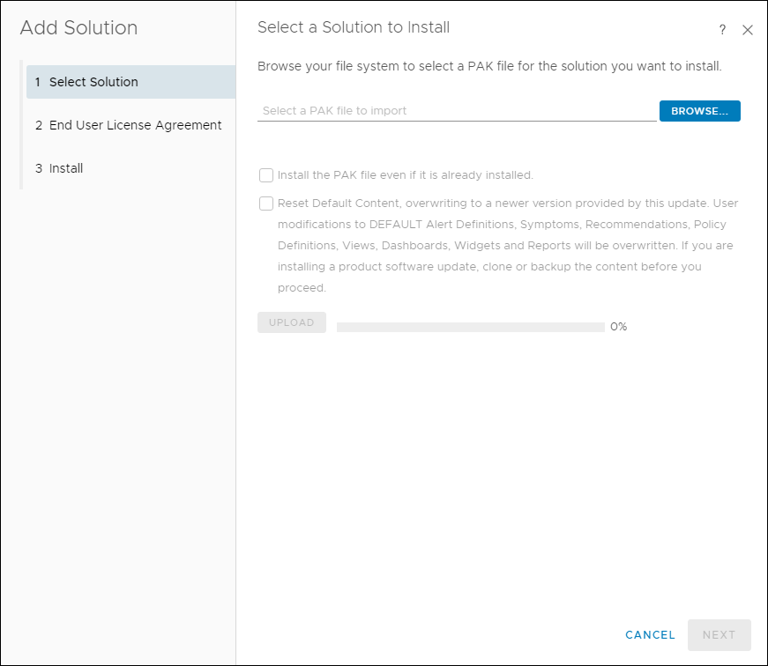

On the **Select Solution** tab page, click **BROWSE** and select the plug-in installation file.

(Optional) Select **Install the PAK file even if it is already installed**.

Click **UPLOAD** and upload the installation file.

Click **NEXT**.

The **Confirmation** dialog box is displayed.

Click **Yes**.

The **End User License Agreement** tab page is displayed, as shown in Figure 2-2.

End User License Agreement

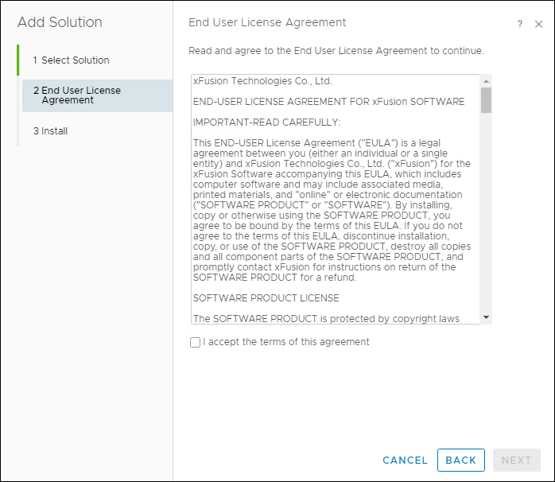

Select **I accept the terms of this agreement** and click **NEXT**.

The **Installation** tab page is displayed.

After the installation is complete, click **FINISH**.

In the lower part of the **Repository** page, view the installed vROps plug-in, as shown in Figure 2-3.

Viewing the installed vROps plug-in

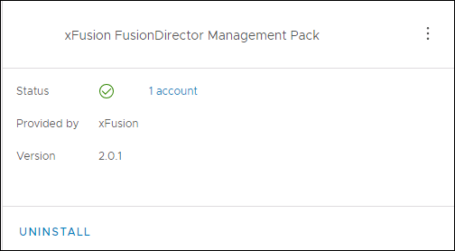

----End

## Uninstallation

On the vROps WebUI, choose **Administration**.

The **Administration** page is displayed.

In the navigation pane on the left, choose **Repository**.

The **Repository** page is displayed.

In the lower part of the page, select the vROps plug-in to be uninstalled and click **UNINSTALL**, as shown in Figure 2-4.

Uninstalling the vROps plug-in

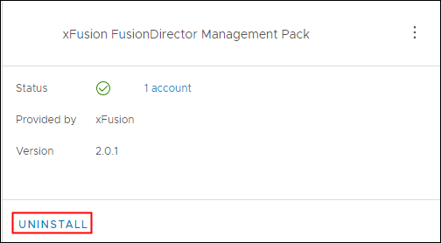

The **Warning** dialog box is displayed, as shown in Figure 2-5.

Warning dialog box

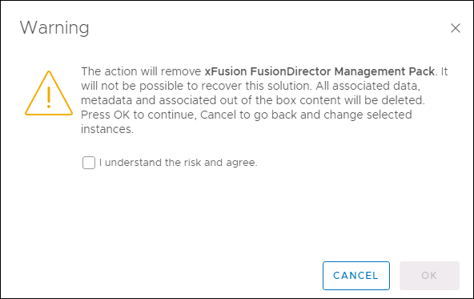

Select **I understand the risk and agree.** and click **OK**.

The vROps plug-in is uninstalled.

----End

## Upgrade

Procedure

(Optional) Uninstall the vROps plug-in of the earlier version. For details, see 2.2 Uninstallation.

Install the vROps plug-in of the new version. For details, see 2.1 Installation.

----End

# Configuring FusionDirector

3.1 Addition

3.2 Modification

3.3 Deletion

## Addition

On the vROps WebUI, choose **Administration**.

The **Administration** page is displayed.

In the navigation tree on the left, choose **Other Accounts**.

The **Other Accounts** page is displayed.

Click **ADD ACCOUNT**.

Select the type of the account to be added, for example, **FusionDirectorAdapter**.

The **New Account** page is displayed, as shown in Figure 3-1.

New Account

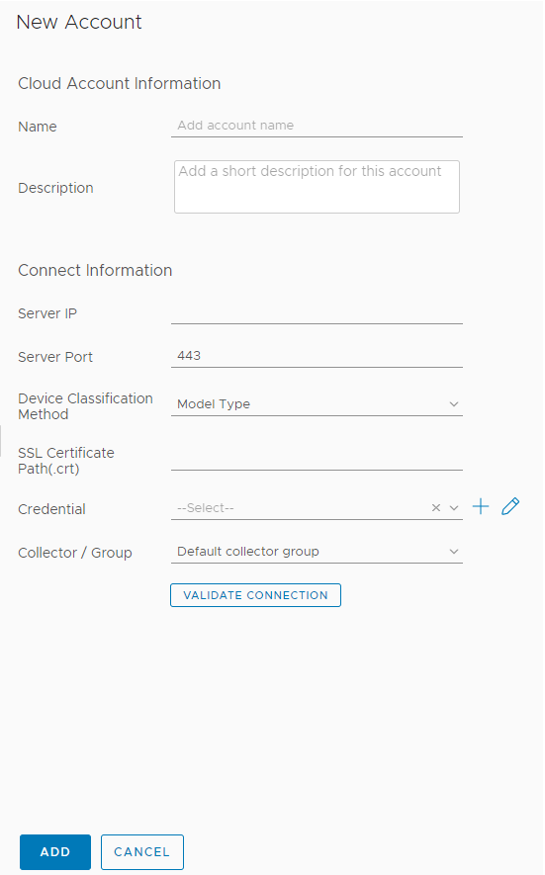

Set the following parameters:

* **Name**: user-defined name to identify different FusionDirector instances
* **Description**: (optional) user-defined description to describe a FusionDirector instance
* **Server IP**: FusionDirector IP address
* **Server Port**: FusionDirector port number, which is **443** by default.
* **Device Classification Method**: way to classify servers
* **Model Type**: type view
* **Group Type**: group view
* **SSL Certificate Path(.crt)**: (optional) path of the certificate in the vROps



You are advised to upload the SSL certificate for security. For details about how to upload the certificate, see Step 6 to Step 7.

(Optional) Obtain the certificate.

1. Access the FusionDirector WebUI.
2. Click **Certificate error** in the address box of the browser.

The **Certificate Invalid** dialog box is displayed, as shown in Figure 3-2.

Invalid certificate

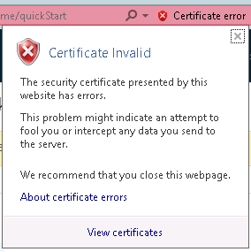

1. Click **View certificates**.

The **Certificate** dialog box is displayed.

1. Click the **Details** tab.

The **Details** tab is displayed, as shown in Figure 3-3.

Details

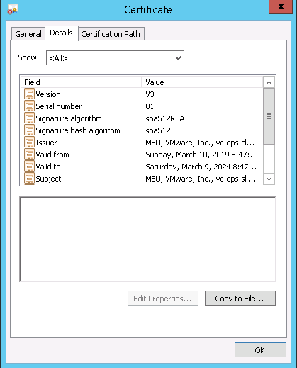

1. Click **Copy to File...**.

The **Certificate Export Wizard** is displayed, as shown in Figure 3-4.

Certificate Export Wizard

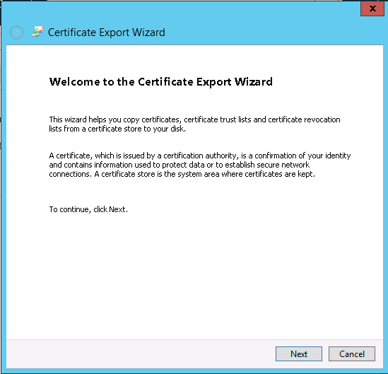

1. Click **Next**. In the **Certificate Export Wizard** dialog box, select **DER encoding binary X.509 (.CER)**, as shown in Figure 3-5.

Setting the format of files to be exported

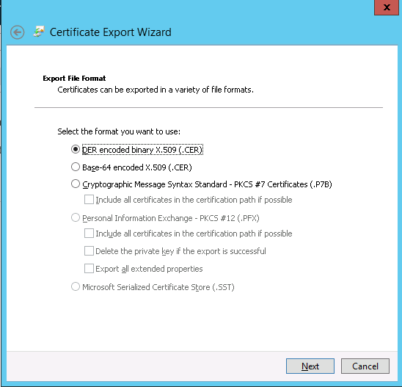

1. Click **Next**. In the **Certificate Export Wizard** dialog box, click **Browse...**, select the certificate export path, and enter the certificate file name, as shown in Figure 3-6.

Service certificate

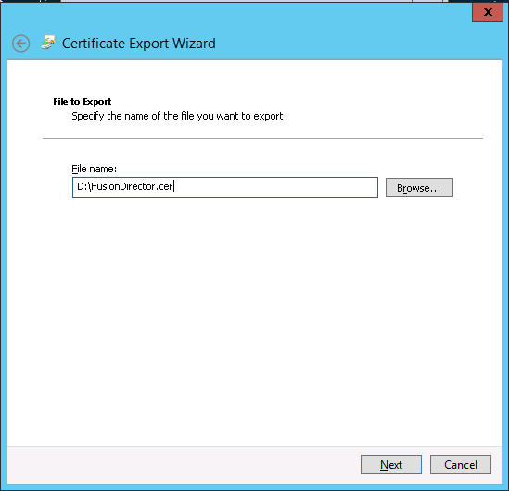

1. Click **Next** to complete certificate export.

(Optional) Import the certificate file to the vROps backend.

1. Configure the SSH access permission for the vROps.
   1. The vROps backend is displayed, as shown in Figure 3-7.

vROps backend

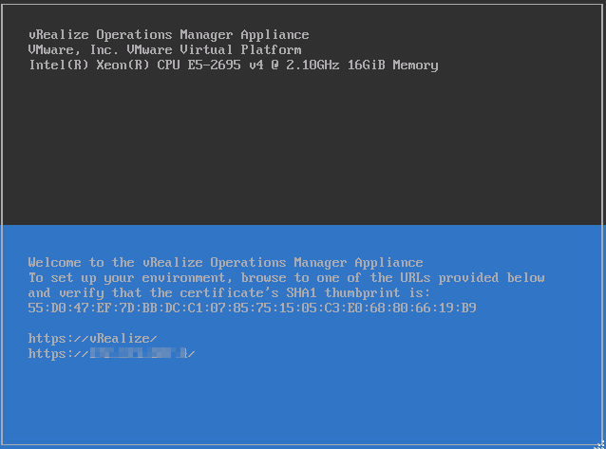

* 1. Press **Alt+F1** and enter the username and password to log in to the vROps, as shown in Figure 3-8.



* The username is **root** and the initial password is blank.
* When you log in for the first time, you need to change the initial password, press **Enter**, enter previous and new passwords, and confirm the new password. The new password must contain uppercase letters, lowercase letters, digits, and special characters.

Logging in to the vROps

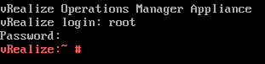

* 1. Run the **vi /etc/ssh/sshd_config** command to edit the configuration file **sshd_config**.

Change the value of **MaxSession** to **20** and the value of **AllowTcpForwarding** to **yes**.

* 1. Run the **service sshd start** command to start the SSHD service.
  2. Run the **chkconfig sshd on** command to enable the SSHD service.
  3. Run the **service vmware-vcops-firewall stop** command to disable the firewall.
  4. Run the **chkconfig vmware-vcops-firewall off** command to disable the firewall upon startup.

1. Use the SSH tool to upload the certificate file to **/usr/lib/vmware-vcops/user/plugins/inbound**.
2. Enter the SSL certificate path **/usr/lib/vmware-vcops/user/plugins/inbound/FusionDirector.crt** in Step 5.

In the **Credential** field, click .



The **Manage Credentials** dialog box is displayed, as shown in Figure 3-9.

Manage Credentials

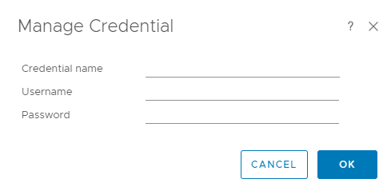

Set the following parameters and click **OK**.

* **Credential name**: user-defined name to identify different credentials
* **Username**: FusionDirector username to access the Redfish API. The default username is **rootRedfish**.
* **Password**: FusionDirector password to access the Redfish API. The default password is **Machine@123**.

Click **VALIDATE CONNECTION**.

If the test connection is successful, a dialog box is displayed, as shown in Figure 3-10. Click **OK**. If the test connection fails, the failure cause is displayed. Modify the FusionDirector information as prompted.

Successful test connection

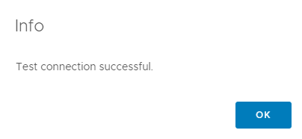

Click **ADD**.

The FusionDirector instance is added.

On the **Other Accounts** page, view the added FusionDirector instance, as shown in Figure 3-11.

Viewing the added account

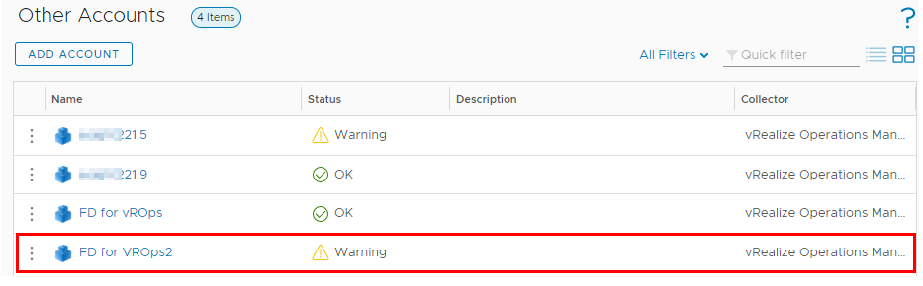

----End

## Modification

On the vROps WebUI, choose **Administration**.

The **Administration** page is displayed.

In the navigation tree on the left, choose **Other Accounts**.

The **Other Accounts** page is displayed, as shown in Figure 3-12.

Other Accounts

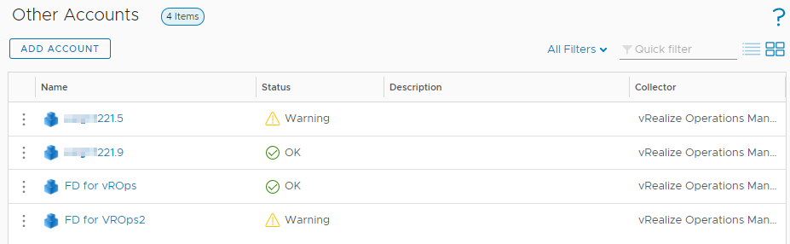

Click the name of the FusionDirector instance to be modified, for example, **FD for vROps**.

The FusionDirector information page is displayed, as shown in Figure 3-13.

FusionDirector information page

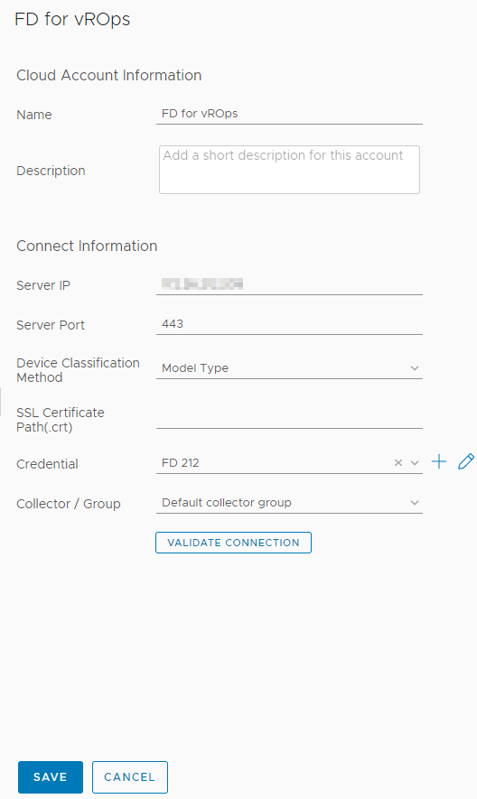

Modify the following parameters as required:

* **Display name**: user-defined name to identify different FusionDirector instances
* **Description**: (optional) user-defined description to describe a FusionDirector instance
* **Server IP**: FusionDirector IP address
* **Server Port**: FusionDirector port number, which is **443** by default.
* **Device Classification Method**: way to classify servers
* **Model Type**: classify servers by type
* **Group Type**: classify servers by group
* **SSL Certificate Path(.crt)**: (optional) path of the certificate in the vROps
* **Credential**: Click to change the credential name, username, and password.



If the FusionDirector port number, username, or password is changed after the FusionDirector connection, you need to synchronize the new port number, user name, or password to the FusionDirector. Otherwise, server management is affected.

Check whether the information in the **Connect Information** area is modified.

* If yes, click **VALIDATE CONNECTION**.

If the test connection is successful, a dialog box is displayed. Click **OK**. If the test connection fails, the failure cause is displayed. Modify the FusionDirector information as prompted.

* If no, go to Step 6.

Click **SAVE**.

The **Other Accounts** page is displayed. You can view the modified FusionDirector information.

----End

## Deletion

On the vROps WebUI, choose **Administration**.

The **Administration** page is displayed.

In the navigation tree on the left, choose **Other Accounts**.

The **Other Accounts** page is displayed, as shown in Figure 3-14.

Other Accounts



Click next to the name of the FusionDirector instance to be deleted.



The operation selection list is displayed.

Click **Delete**.

A confirmation dialog box is displayed, as shown in Figure 3-15.

Deletion confirmation dialog box

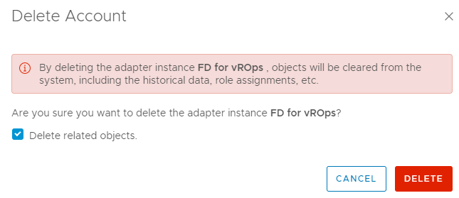

Select **Delete related objects.** (which is selected by default) and click **DELETE**.

The FusionDirector instance is deleted.

----End

# Querying Server Information

4.1 Querying Servers

4.2 Querying Component Information

4.3 Querying Component Group Information

4.4 Querying Server Information

4.5 Querying Server Type Information

4.6 Querying the FusionDirector Information

## Querying Servers

On the vROps WebUI, choose **Environment**.

The **Environment** page is displayed.

In the navigation pane, choose **xFusion FusionDirector Management Pack** > **xFusion Servers**.

The **xFusion Servers** page is displayed.

In the navigation pane, view the list of all servers, as shown in Figure 4-1 and Figure 4-2.

xFusion servers by Model Type

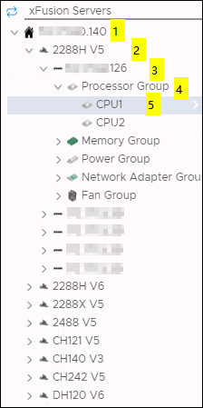

* 1: FusionDirector IP address
* 2: Server model
* 3: Server label and iBMC IP address. If no label is set for the server, only the iBMC IP address is displayed. For details about how to set the server label, see the [*FusionDirector Operation Guide*](https://support.xfusion.com/support/#/en/fusiondirector/fusiondirector-pid-23015464/document?category=C12&subcategory=C0026).
* 4: Component group
* 5: A component

xFusion servers by Group Type

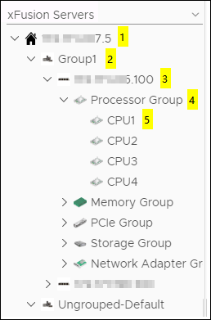

* 1: FusionDirector IP address
* 2: Server group name, which can be set in the FusionDirector. For details, see the [*FusionDirector Operation Guide*](https://support.xfusion.com/support/#/en/fusiondirector/fusiondirector-pid-23015464/document?category=C12&subcategory=C0026).
* 3: Server label and iBMC IP address. If no label is set for the server, only the iBMC IP address is displayed. For details about how to set the server label, see the [*FusionDirector Operation Guide*](https://support.xfusion.com/support/#/en/fusiondirector/fusiondirector-pid-23015464/document?category=C12&subcategory=C0026).
* 4: Component type
* 5: A component

----End

## Querying Component Information

On the vROps WebUI, select **Environment**.

The **Environment** page is displayed.

In the navigation pane, choose **xFusion FusionDirector Management Pack** > **xFusion Servers**.

The **xFusion Servers** page is displayed.

Select a FusionDirector IP address, a server model (by Group Type), a server, a component group, and a component, as shown in Figure 4-3.

Component information

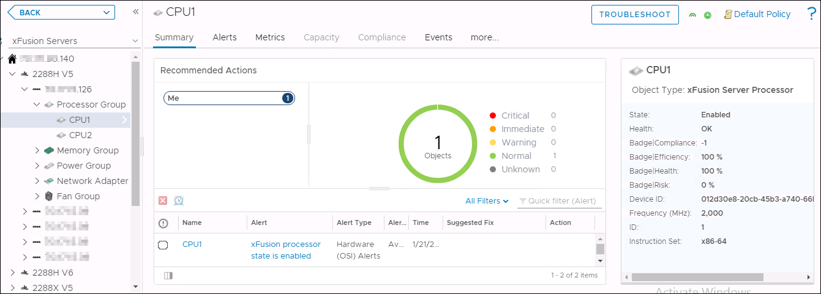

View the summary of the component.

1. Click **Summary**.

The **Summary** page is displayed.

1. In the **Recommended Actions** area, view the running status and alarm information about the component, as shown in Figure 4-4.

Viewing the summary

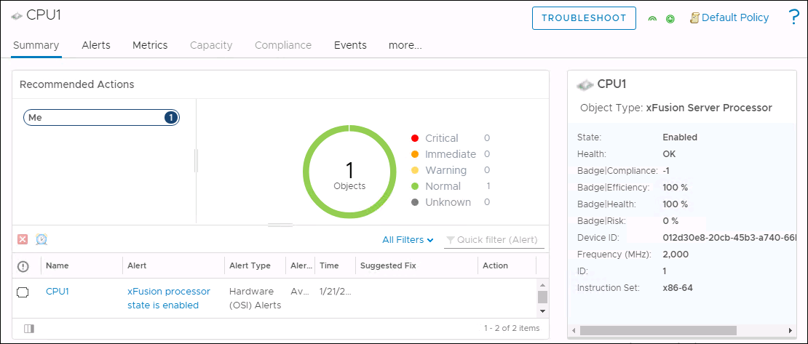

View warning information of the component.

1. Click **Alerts**.

The **Alerts** page is displayed.

1. Select a grouping mode, for example, **Object Type**.
2. Click to expand the warning list.



1. Click a warning name to view details about the warning.

Viewing warning information

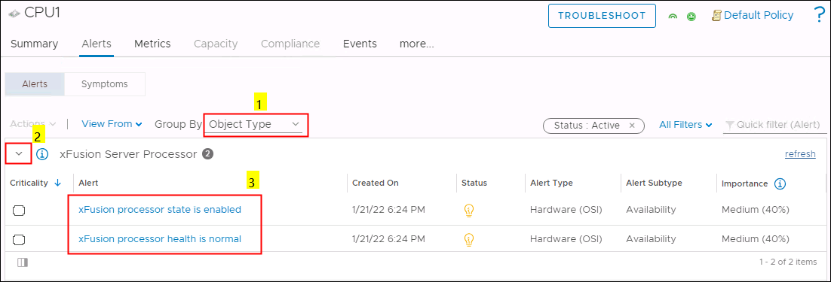

View the real-time status curve of the component.

1. Click **Metrics**.

The **Metrics** page is displayed.

Metrics

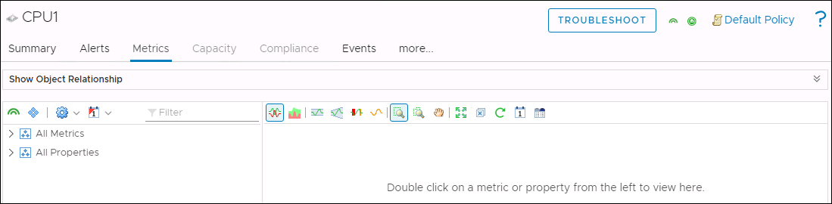

1. Click to expand the information list under **All Metrics** or **All Properties**.



1. Double-click the real-time status information to be viewed. For example, double-click **Health**, as shown in Figure 4-7.

You can view the real-time status curve in the right pane.

Viewing the real-time status curve

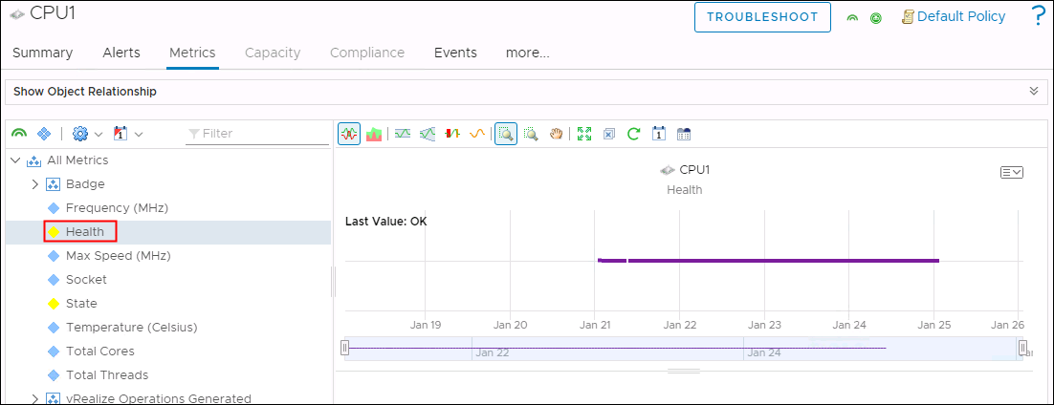

View details about a component view.

1. Click **more** > **Details**.

The **Details** page is displayed.

1. Select a view.
2. View details about the view.

Viewing details about the view

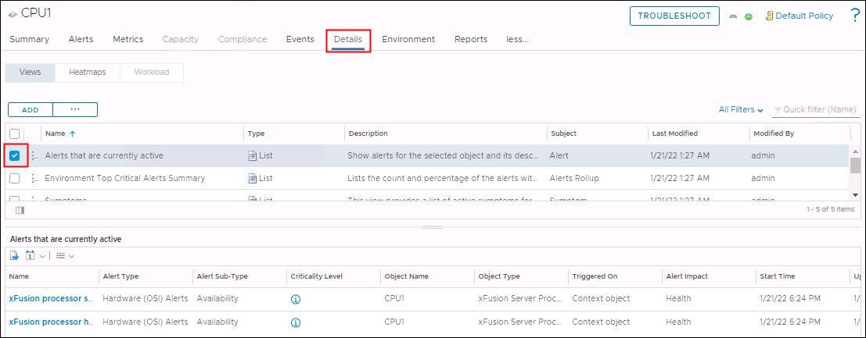

----End

## Querying Component Group Information

On the vROps WebUI, choose **Environment**.

The **Environment** page is displayed.

In the navigation pane, choose **xFusion FusionDirector Management Pack** > **xFusion Servers**.

The **xFusion Servers** page is displayed.

Select a FusionDirector IP address, a server model (by **Group Type**), a server, and a component group, as shown in Figure 4-9.

Component group information

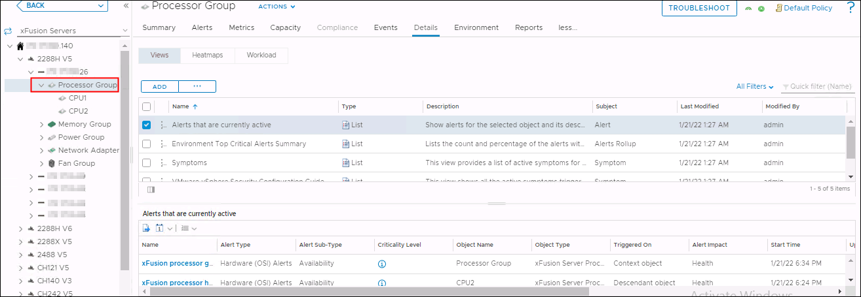

See 4.2 Querying Component Information to view the summary, warnings, details, and real-time status curves of all components in the component group.

----End

## Querying Server Information

On the vROps WebUI, choose **Environment**.

The **Environment** page is displayed.

In the navigation pane, choose **xFusion FusionDirector Management Pack** > **xFusion Servers**.

The **xFusion Servers** page is displayed.

Select a FusionDirector IP address, a server model (by **Group Type**), and a server, as shown in Figure 4-10.

Server information

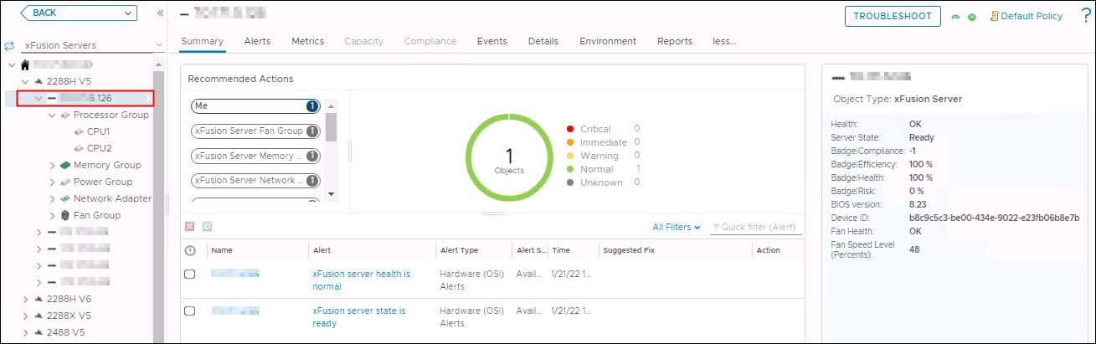

See 4.2 Querying Component Information to view the summary, warnings, details, and real-time status curves of all components of the server.

----End

## Querying Server Type Information

On the vROps WebUI, choose **Environment**.

The **Environment** page is displayed.

In the navigation pane, choose **xFusion FusionDirector Management Pack** > **xFusion Servers**.

The **xFusion Servers** page is displayed.

Select a FusionDirector IP address and a server model (by Group Type), as shown in Figure 4-11.

Server type

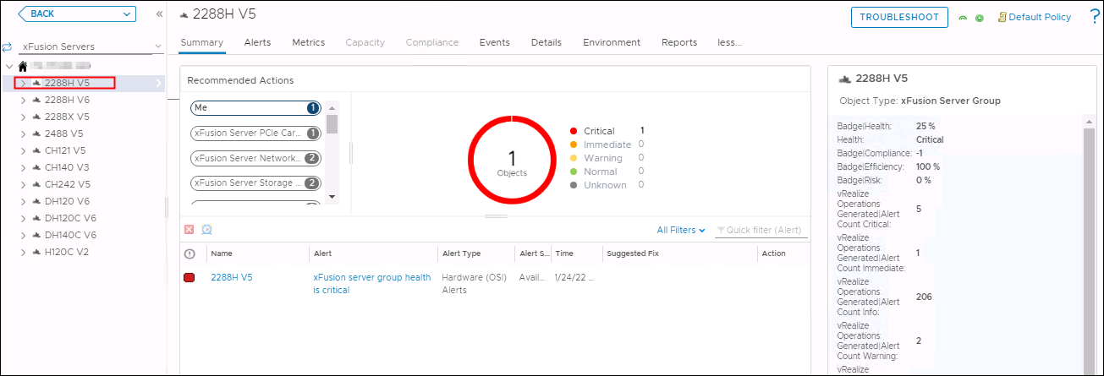

See 4.2 Querying Component Information to view the summary, warnings, details, and real-time status curves of all components of the server type.

----End

## Querying the FusionDirector Information

On the vROps WebUI, choose **Environment**.

The **Environment** page is displayed.

In the navigation pane, choose **xFusion FusionDirector Management Pack** > **xFusion Servers**.

The **xFusion Servers** page is displayed.

Select a FusionDirector IP address, as shown in Figure 4-12.

FusionDirector information

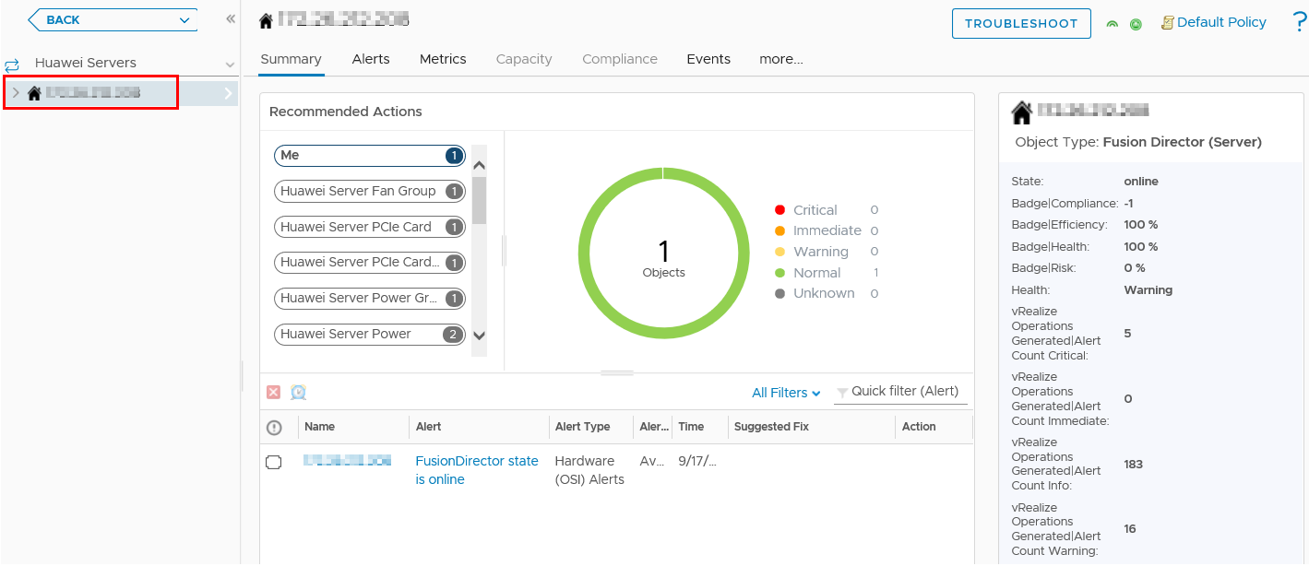

See 4.2 Querying Component Information to view the summary, warnings, details, and real-time status curves of all components of the FusionDirector instance.

----End

# Querying Enclosure Information

5.1 Querying Enclosures

5.2 Querying Component Information

5.3 Querying Component Group Information

5.4 Querying Enclosure Information

5.5 Querying the FusionDirector Information

## Querying Enclosures

On the vROps WebUI, choose **Environment**.

The **Environment** page is displayed.

In the navigation pane, choose **xFusion FusionDirector Management Pack** > **xFusion Enclosures**.

The **xFusion Enclosures** page is displayed.

In the navigation pane, view the list of all enclosures, as shown in Figure 5-1.

xFusion enclosures

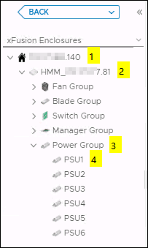

* 1: FusionDirector IP address
* 2: Enclosure name and iBMC IP address
* 3: Component group
* 4: A component

----End

## Querying Component Information

On the vROps WebUI, choose **Environment**.

The **Environment** page is displayed.

In the navigation pane, choose **xFusion FusionDirector Management Pack** > **xFusion Enclosures**.

The **xFusion Enclosures** page is displayed.

Select a FusionDirector IP address, an enclosure, a component group, and a component, as shown in Figure 5-2.

Component information

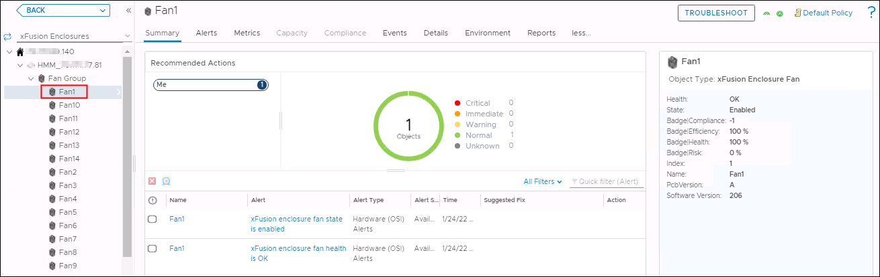

View the summary of the component.

1. Click **Summary**.

The **Summary** page is displayed.

1. In the **Recommended Actions** area, view the running status and alarm information about the component, as shown in Figure 5-3.

Viewing the summary

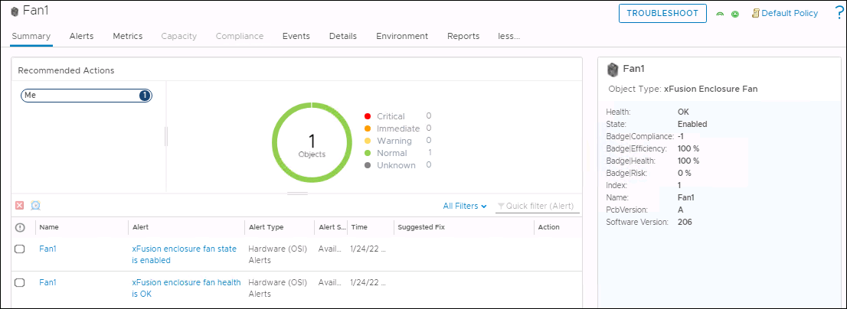

View warning information of the component.

1. Click **Alerts**.

The **Alerts** page is displayed.

1. Select a grouping mode, for example, **Object Type**.
2. Click to expand the warning list.



1. Click a warning name to view details about the warning.

Viewing warning information

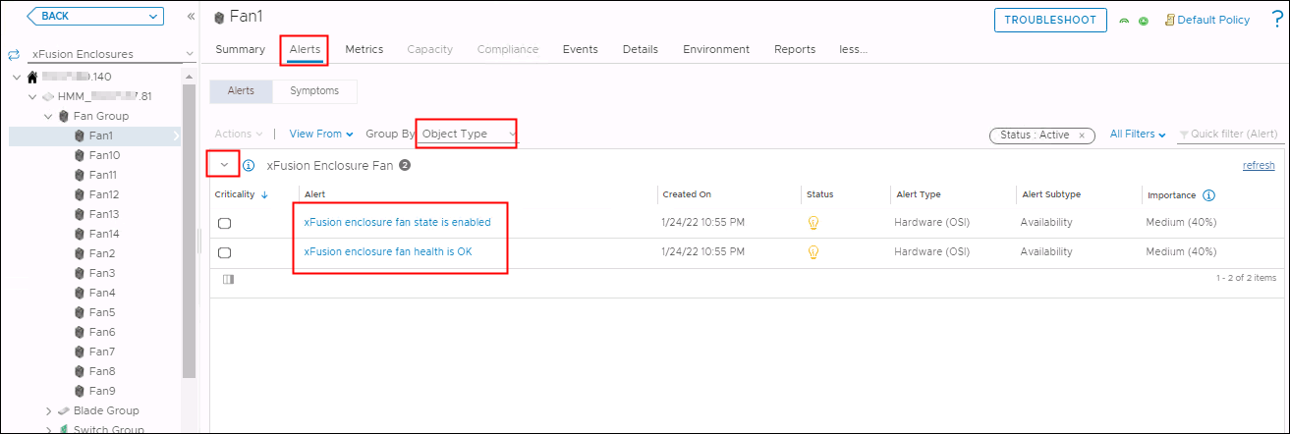

View the real-time status curve of the component.

1. Click **Metrics**.

The **Metrics** page is displayed.

Metrics

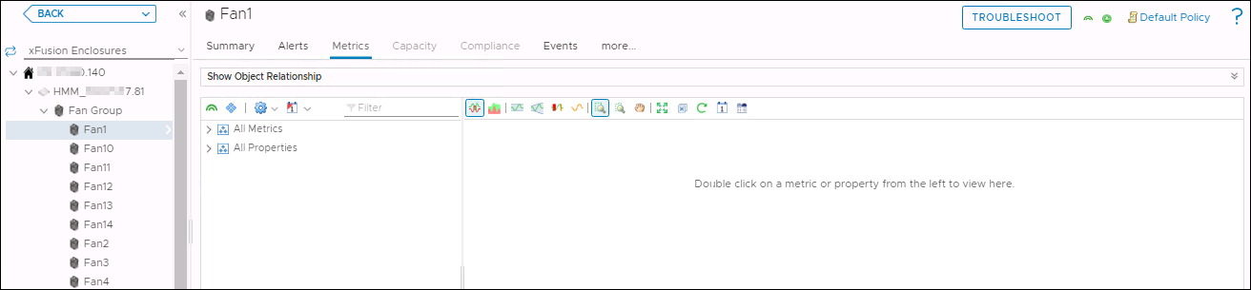

1. Click to expand the information list under **All Metrics** or **All Properties**.



1. Double-click the real-time status information to be viewed. For example, double-click **Health**, as shown in Figure 5-6.

You can view the real-time status curve in the right pane.

Viewing the real-time status curve

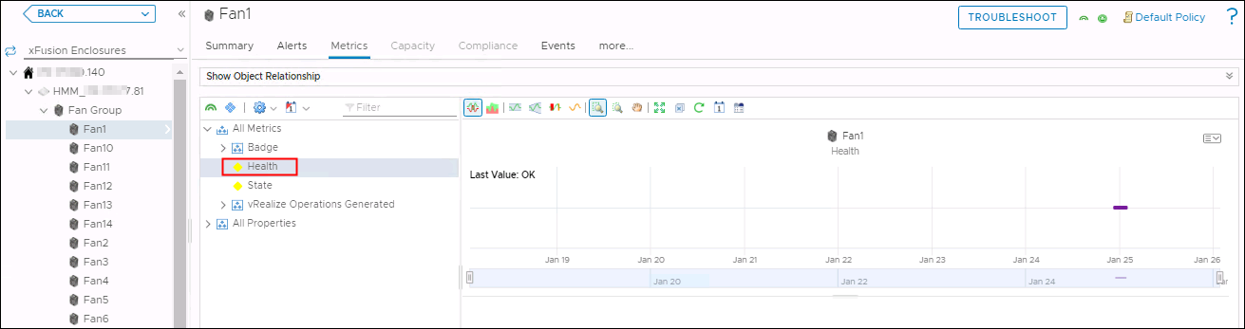

View details about a component view.

1. Click **more** > **Details**.

The **Details** page is displayed.

1. Select a view.
2. View details about the view.

Viewing details about the view

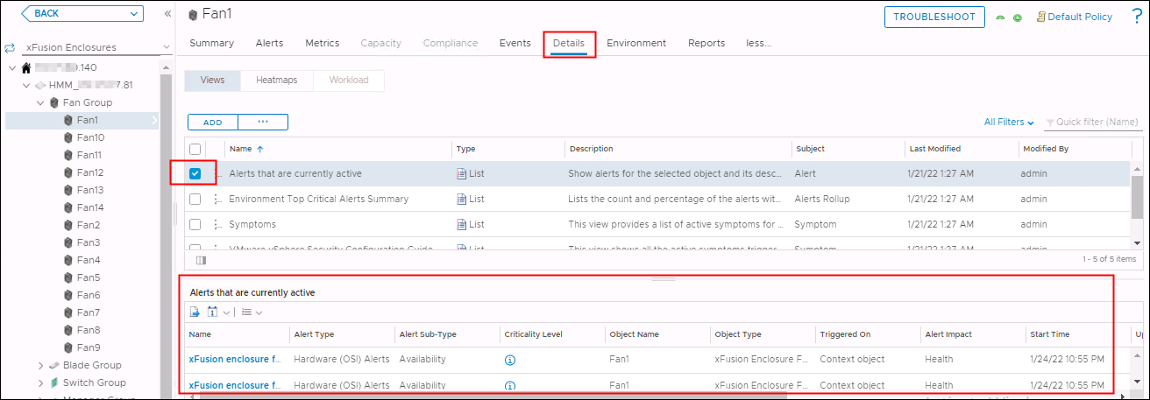

----End

## Querying Component Group Information

On the vROps WebUI, choose **Environment**.

The **Environment** page is displayed.

In the navigation pane, choose **xFusion FusionDirector Management Pack** > **xFusion Enclosures**.

The **xFusion Enclosures** page is displayed.

Select a FusionDirector IP address, an enclosure, and a component group, as shown in Figure 5-8.

Component group information

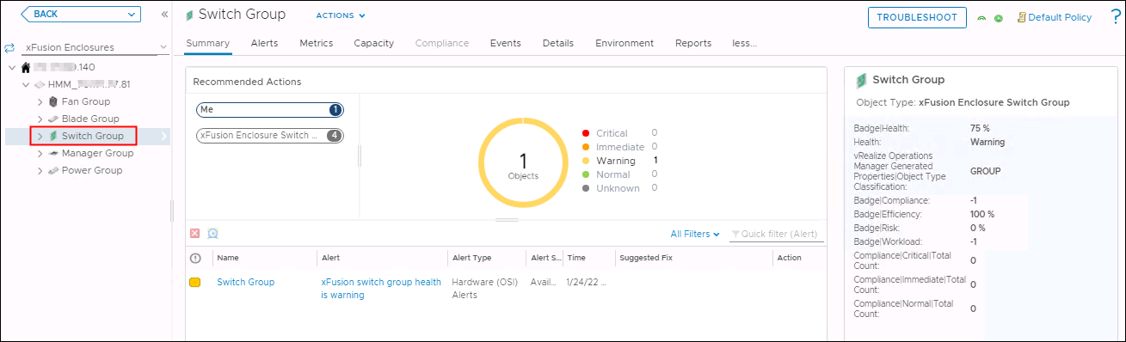

See 5.2 Querying Component Information to view the summary, warnings, details, and real-time status curves of all components in the component group.

----End

## Querying Enclosure Information

On the vROps WebUI, choose **Environment**.

The **Environment** page is displayed.

In the navigation pane, choose **xFusion FusionDirector Management Pack** > **xFusion Enclosures**.

The **xFusion Enclosures** page is displayed.

Select a FusionDirector IP address and an enclosure, as shown in Figure 5-9.

Enclosure information

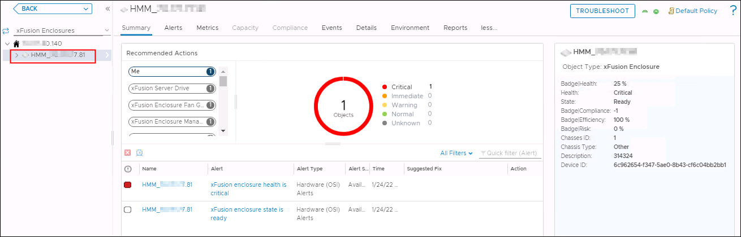

See 5.2 Querying Component Information to view the summary, warnings, details, and real-time status curves of all components of the enclosure.

----End

## Querying the FusionDirector Information

On the vROps WebUI, choose **Environment**.

The **Environment** page is displayed.

In the navigation pane, choose **xFusion FusionDirector Management Pack** > **xFusion Enclosures**.

The **xFusion Enclosures** page is displayed.

Select a FusionDirector IP address, as shown in Figure 5-10.

FusionDirector information

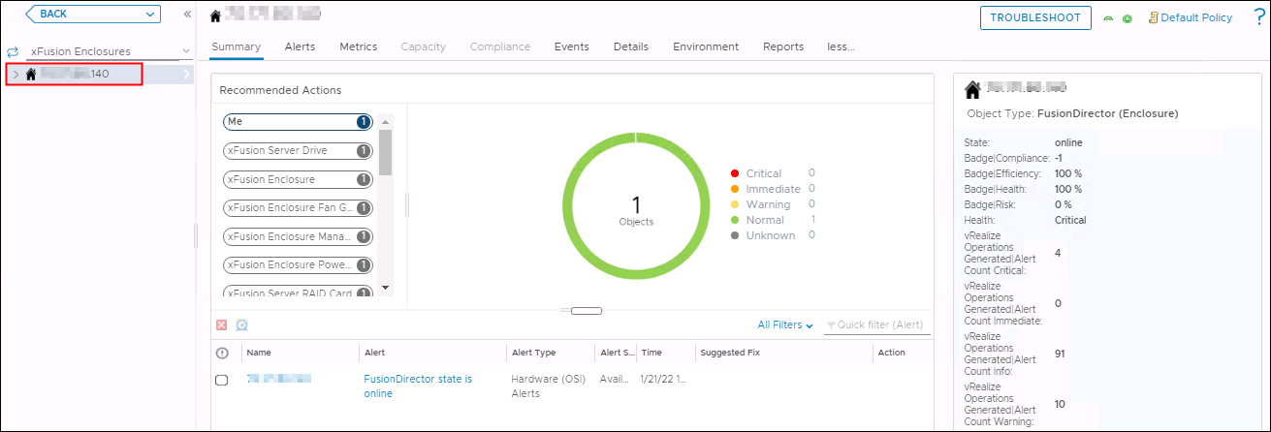

See 5.2 Querying Component Information to view the summary, warnings, details, and real-time status curves of all components of the FusionDirector instance.

----End

# Querying Dashboard Information

6.1 Querying the FusionDirector Overview Dashboard

6.2 Querying xFusion Servers Overview Dashboard

6.3 Querying xFusion Server Detailed Dashboard

6.4 Querying xFusion Enclosure Overview Dashboard

6.5 Querying xFusion Enclosure Detailed Dashboard

## Querying the FusionDirector Overview Dashboard

On the vROps WebUI, choose **Dashboards**.

The **Dashboards** page is displayed.

In the navigation pane, choose **Dashboards** > **Fusion Director Overview Dashboard**.

The **Fusion Director Overview Dashboard** page is displayed.

You can view the FusionDirector name, adapter type, object type, policy, collection state, collection status, server IP address, port, state, FusionDirector version, and classification method, as shown in Figure 6-1.

FusionDirector Overview Dashboard

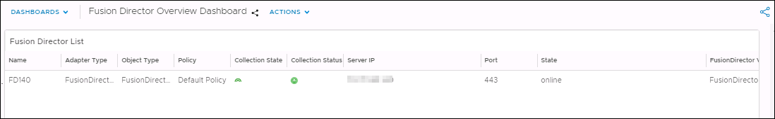

----End

## Querying xFusion Servers Overview Dashboard

On the vROps WebUI, choose **Dashboards**.

The **Dashboards** page is displayed.

In the navigation pane, choose **Dashboards** > **xFusion Servers Overview Dashboard**.

The **xFusion Servers Overview Dashboard** page is displayed.

You can view the following information, as shown in Figure 6-2.

* Servers Environment Health
* Servers Latest Alerts
* Top High Power Consumption Servers
* Top High Inlet Temperature Servers
* Top High Fan Speed On Average Servers
* Select About for Power Consumption Trend
* Select About for Temperature Trend
* Select About for Fan Speed Trend

xFusion Servers Overview Dashboard

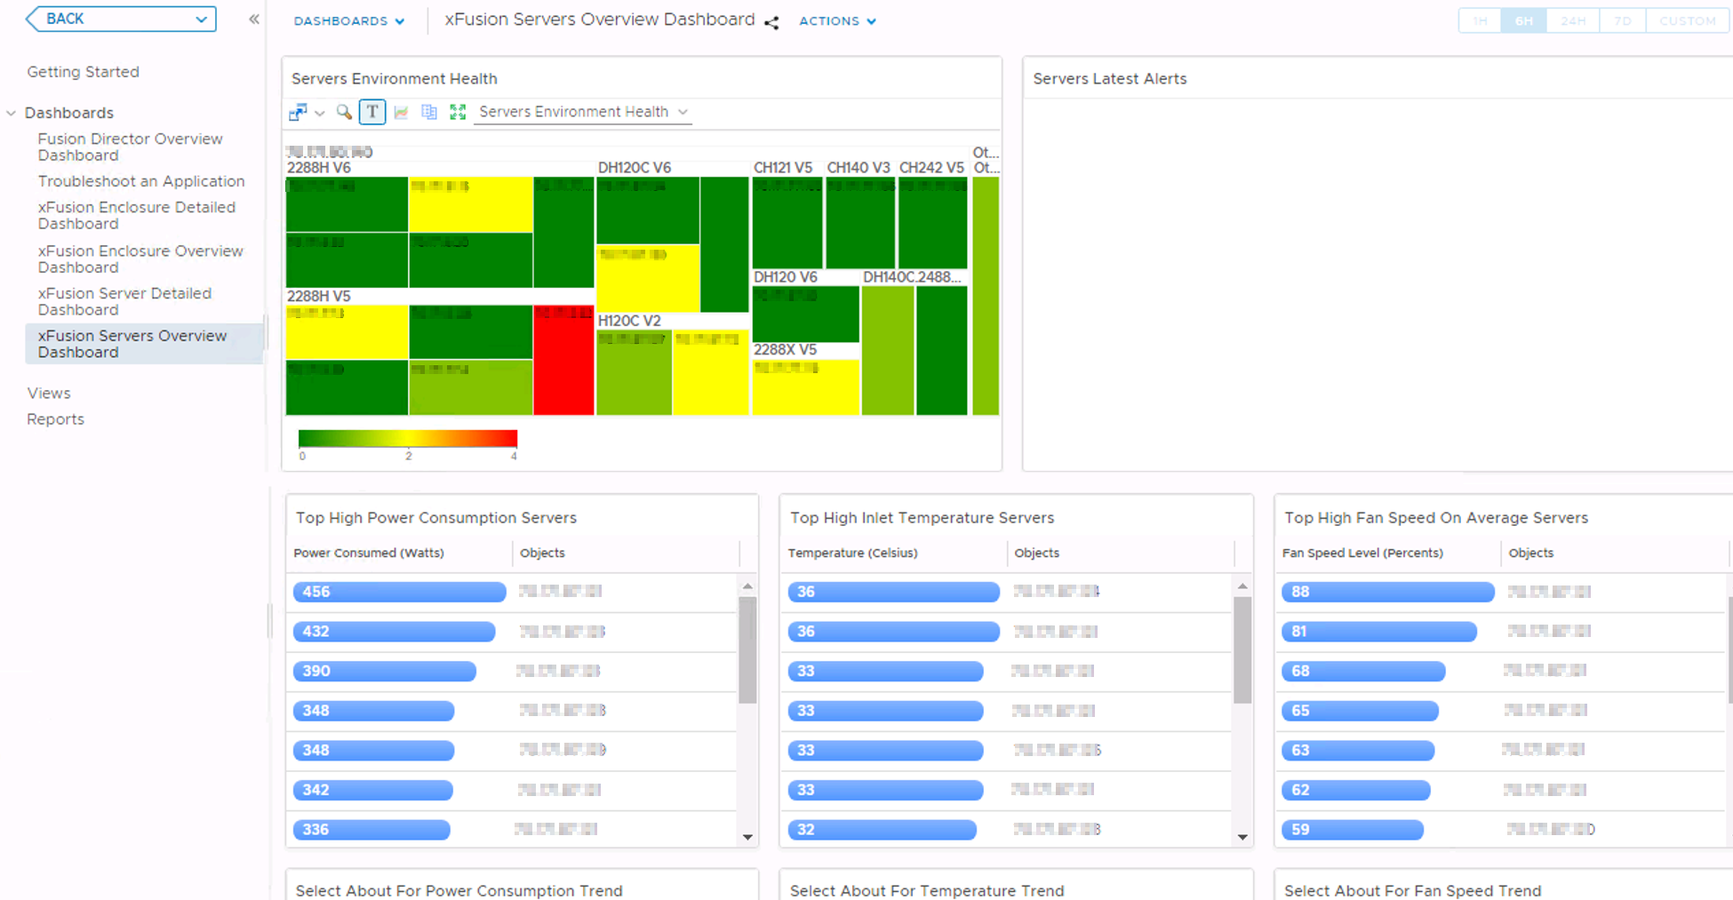

In the **Servers Environment Heath** area, select a server. You can view the latest alarms of the server in the **Servers Latest Alerts** area, as shown in Figure 6-3.

xFusion Servers Latest Alerts

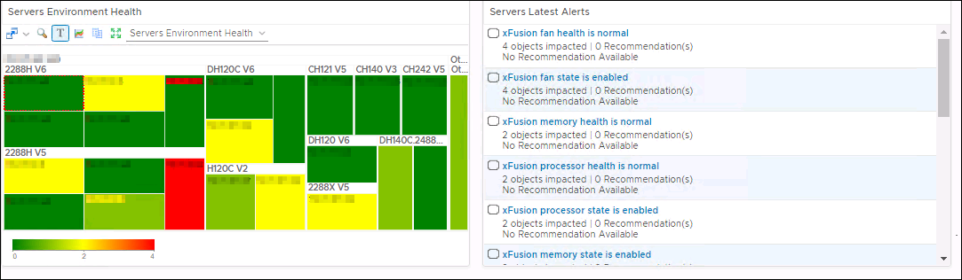

In the **Top High Power Consumption Servers** area, select different servers. You can view power consumption trends of these servers in the **Select About For Power Consumption Trend** area, as shown in Figure 6-4.

Power consumption trend

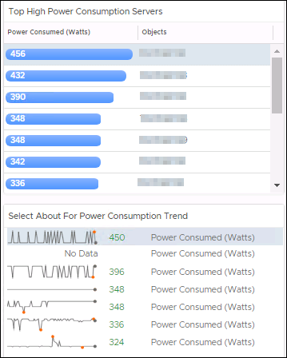

In the **Top High Inlet Temperature Servers** area, select different servers. You can view temperature trends of these servers in the **Select About For Temperature Trend** area, as shown in Figure 6-5.

Temperature trend

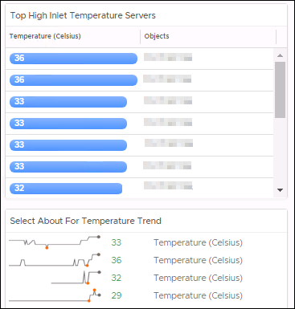

In the **Top High Fan Speed On Average Servers** area, select different servers. You can view fan speed trends of these servers in the **Select About For Fan Speed Trend** area, as shown in Figure 6-6.

Fan speed trend

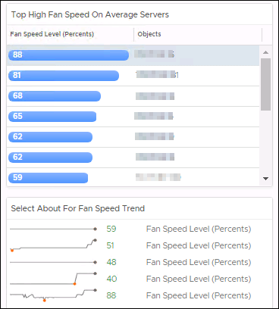

----End

## Querying xFusion Server Detailed Dashboard

On the vROps WebUI, choose **Dashboards**.

The **Dashboards** page is displayed.

In the navigation pane, choose **Dashboards** > **xFusion Server Detailed Dashboard**.

The **xFusion Server Detailed Dashboard** page is displayed.

In the **xFusion Server List** area, select the server to be viewed.

You can view the following information, as shown in Figure 6-7.

* Object Relationship
* Latest Alerts
* Server Power Consumed Metric Chart

xFusion Server Detailed Dashboard

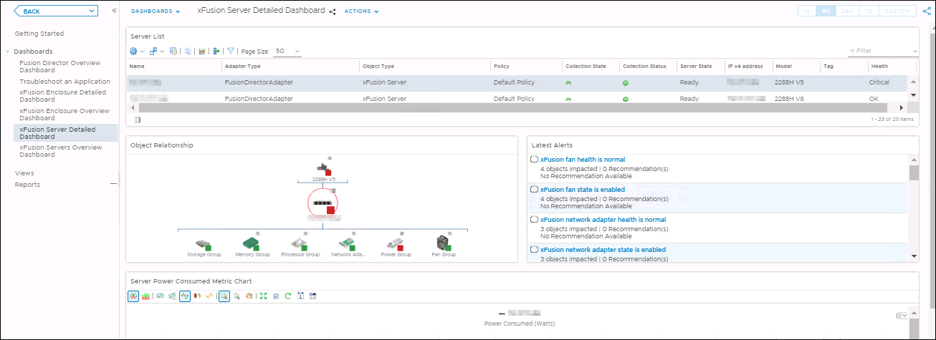

The server topology is displayed in the **Object Relationship** area. You can click any server or component to view the alerts and detailed information about the server or component, as shown in Figure 6-8.

Object Relationship

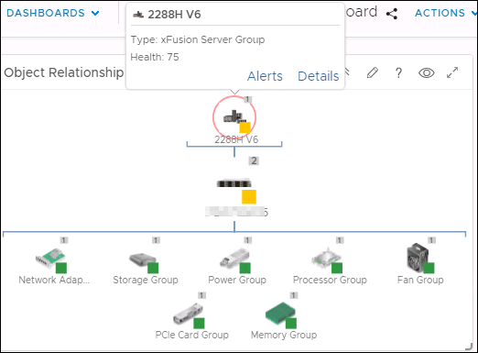

----End

## Querying xFusion Enclosure Overview Dashboard

On the vROps WebUI, choose **Dashboards**.

The **Dashboards** page is displayed.

In the navigation pane, choose **Dashboards** > **xFusion Enclosure Overview Dashboard**.

The **xFusion Enclosure Overview Dashboard** page is displayed.

You can view the following information, as shown in Figure 6-9.

* Enclosure Environment Health
* Enclosure Latest Alerts

xFusion Enclosure Overview Dashboard

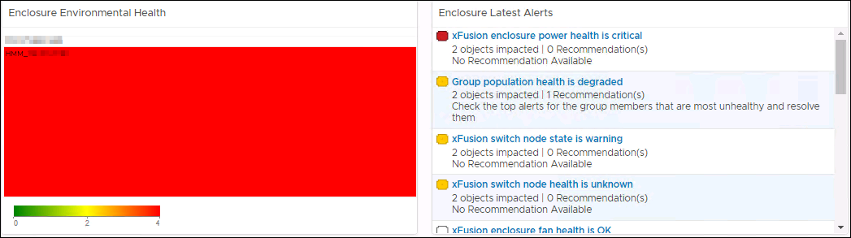

----End

## Querying xFusion Enclosure Detailed Dashboard

On the vROps WebUI, choose **Dashboards**.

The **Dashboards** page is displayed.

In the navigation pane, choose **Dashboards** > **xFusion Enclosure Detailed Dashboard**.

The **xFusion Enclosure Detailed Dashboard** page is displayed.

In the **Enclosure List** area, select the enclosure to be viewed.

You can view the following information, as shown in Figure 6-10.

* Latest Alerts
* Object Relationship

xFusion Enclosure Detailed Dashboard

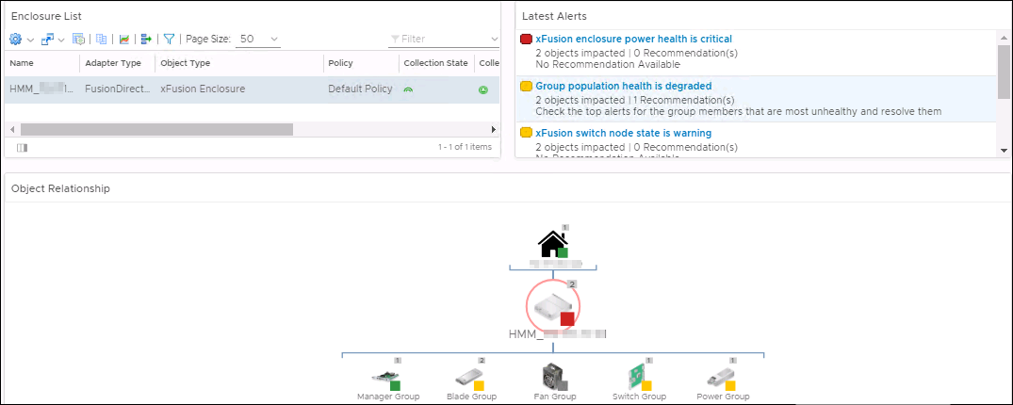

The enclosure topology is displayed in the **Object Relationship** area. You can click any enclosure or component to view the alerts and detailed information about the enclosure or component, as shown in Figure 6-11.

Object Relationship

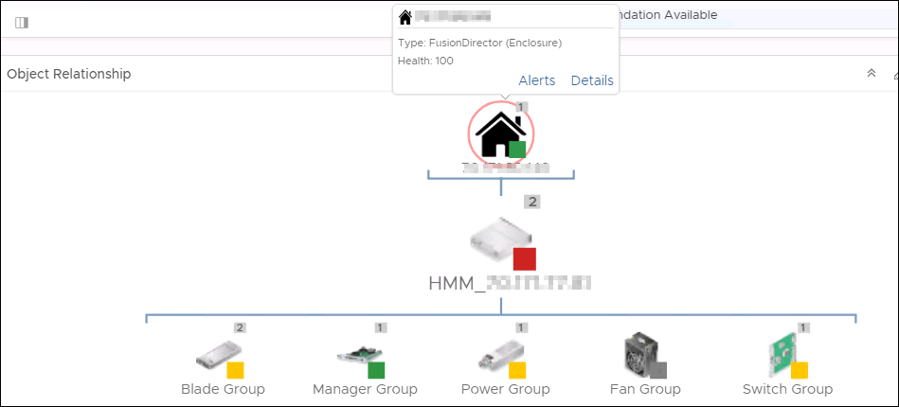

----End

# Viewing Alerts

On the vROps WebUI, choose **Alerts**.

The **Alerts** page is displayed.

In the navigation pane, choose **Triggered Alerts**.

The **Triggered Alerts** page is displayed.

Select **Object Type** from the **Group By** drop-down list box.

In the alarm column of the component for which the alarm is generated, click to expand the list and click **Triggered On**, as shown in Figure 7-1.



You can only select a component, not a component group. Otherwise, the alerted server cannot be located.

All alerts

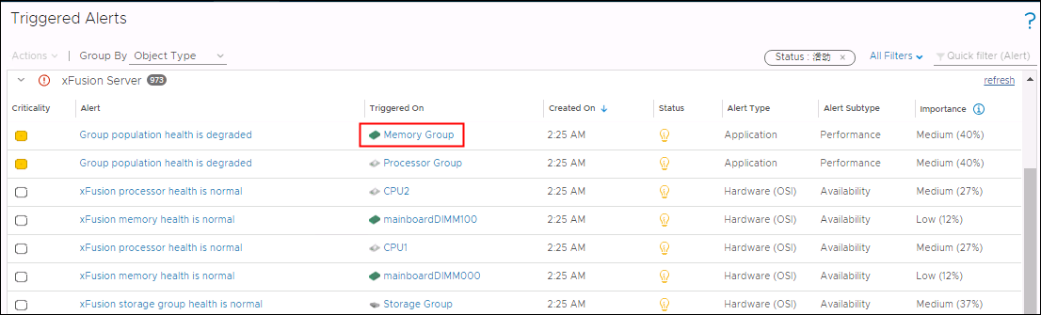

The page about the triggered object is displayed, as shown in Figure 7-2.

Triggered object

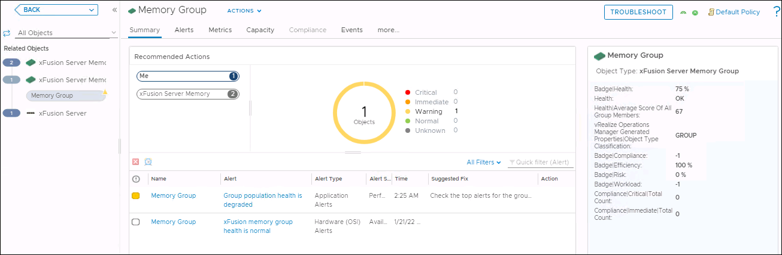

In the navigation tree on the left, click an object (such as xFusion Server Group or xFusion Server) to view the server to which the trigger object belongs.

----End

# Querying the xFusion vROps Plug-in Version

On the vROps WebUI, choose **Administration**.

The **Administration** page is displayed.

In the navigation pane on the left, choose **Repository**.

The **Repository** page is displayed.

Check the current version of the vROps plug-in, as shown in Figure 8-1.

Viewing the plug-in version

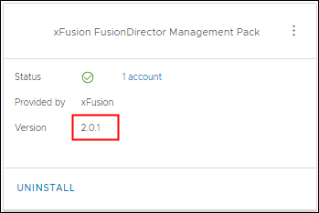

----End

1. Obtaining Technical Support

To obtain assistance, contact technical support as follows:

* Contact customer service center at [support@xfusion.com](mailto:support@xfusion.com).
* Contact technical support personnel.